ASP.Net Core MVC (.Net 6.0) CRUD Operation

Introduction

We will learn CRUD (Create, Read, Update, and Delete) operations in ASP.NET Core MVC (.Net 6.0). We will use Entity Framework Core 6 to interact with the SQL Server database. We will use two Entity for CRUD operation.

**Cover the following points in this blog.**

* Create ASP.NET Core MVC 6.0 project in visual studio 2022
* Install all the necessary packages from NuGet.
* Create entities in the Model folder.
* Crete ApplicationDbContext class to interact with Database
* Add connection string of SQL Server database into appsettings.json file
* Run migration commands inside Package Manager Console (PMC)
  + Add-Migration "Initial"
  + Update-Database
* Add controllers inside the controller folder
* Add view models
* Add Views
* Add Validation

**Prerequisites**

* Visual Studio 2022 (.Net 6.0)
* SQL Server

**Step 1**. Create ASP.NET Core MVC 6 project

First, open Visual Studio 2022 and click on**"Create a New Project" (**highlighted in yellow color**)**

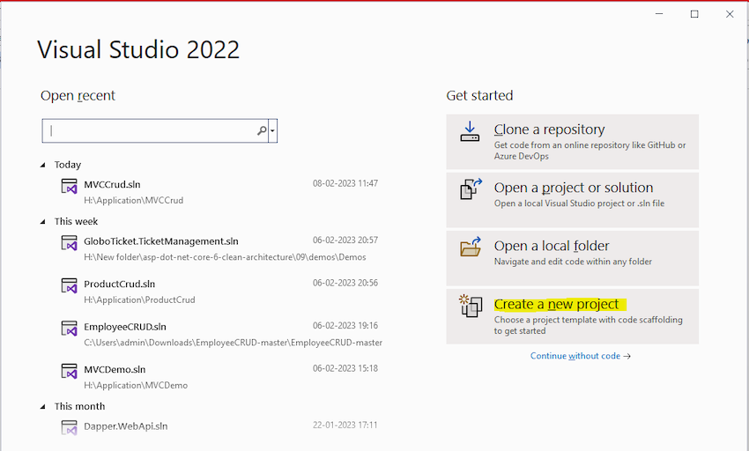

Search "**MVC**" in the Search box**(Search for templates (Alt+s))**and select**ASP.NET Core Web App (Model-View-Controller)**as a project template and click**the Next**button**.**

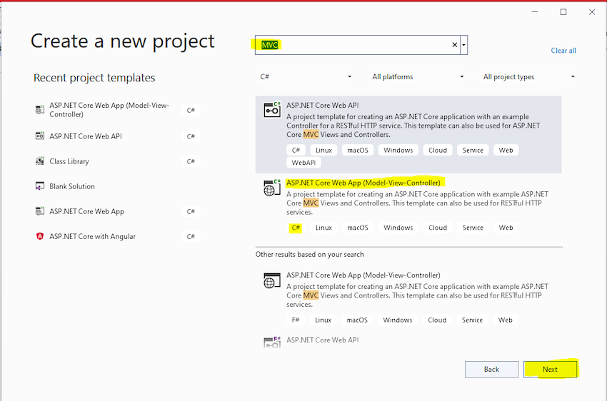

Enter a project name and click next.

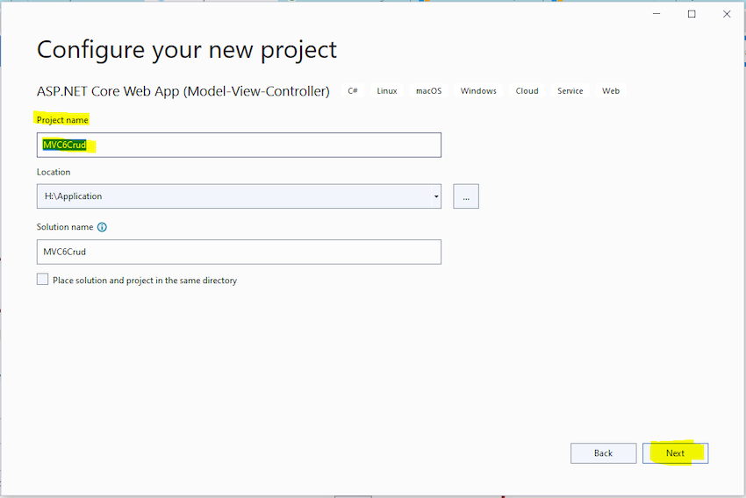

Go with the basic configuration as per the below screen; click**Next.**

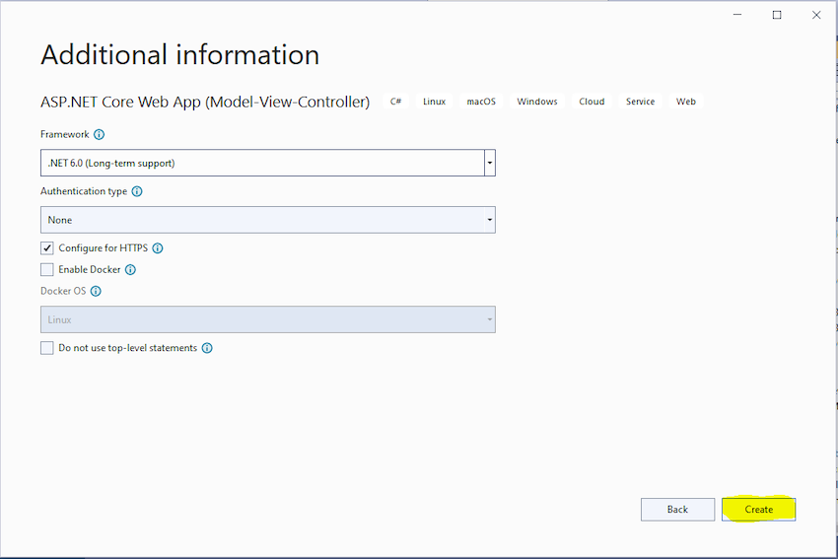

**ASP.NET Core MVC (.Net 6.0) project structure**

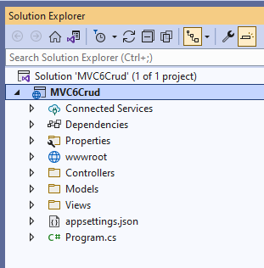

**Step 2**. Install the required package from NuGet

Required package for ASP.NET Core MVC (.Net 6.0) CRUD operation application

* Microsoft.EntityFrameworkCore
* Microsoft.EntityFrameworkCore.SqlServer
* Microsoft.EntityFrameworkCore.Tools

Now, we install the above package one by one**.**Right-click on**Dependencies**and select**"Manage NuGet Packages…"**

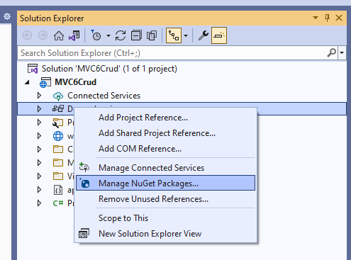

Install **Microsoft.EntityFrameworkCore**package**.**

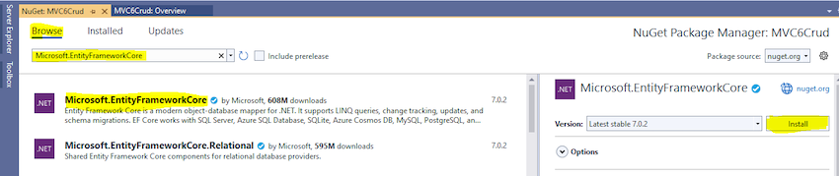

Install **Microsoft.EntityFrameworkCore.SqlServer**package**.**

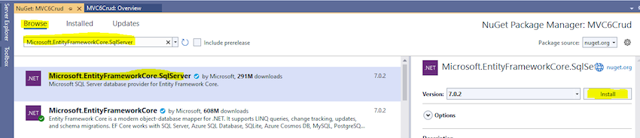

Install **Microsoft.EntityFrameworkCore.Tools**package**.**

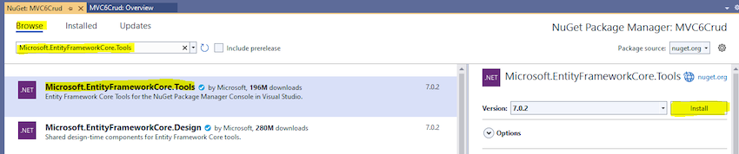

All install packages are showing in **Dependencies -> Packages**

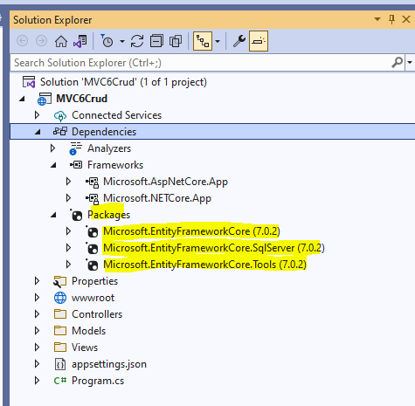

**Step 3**. Add **Category** and **Product** entities class into the **Model** folder

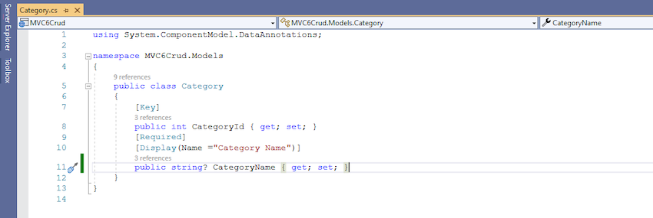

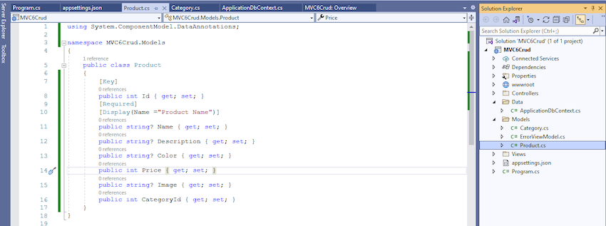

**Step 4.**Add **ApplicationDbContext**class inside the **Data** folder

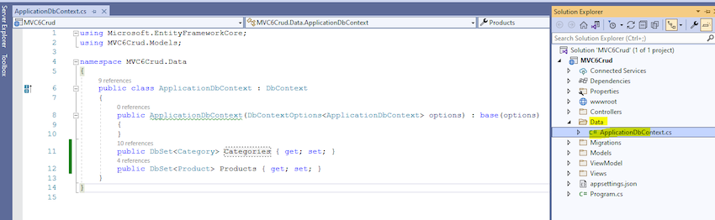

**Step 5.**Add **connectionstring** into **appsettings.json**

"ConnectionStrings": {

"MVC6CrudConnetionString": "Data Source=DESKTOP-LOPK1F2;Integrated Security=true;Initial Catalog=MVC6CrudDb;TrustServerCertificate=True;MultipleActiveResultSets=true;"

}

Markup

Copy

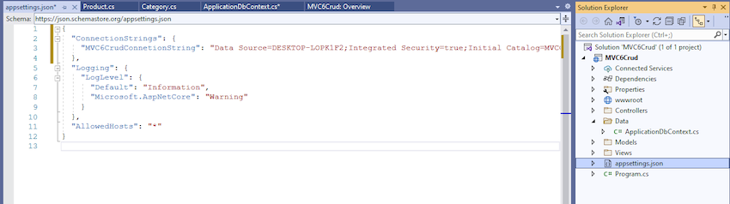

**Step 6.** Add DbContext Service into Program.cs file with the connection string

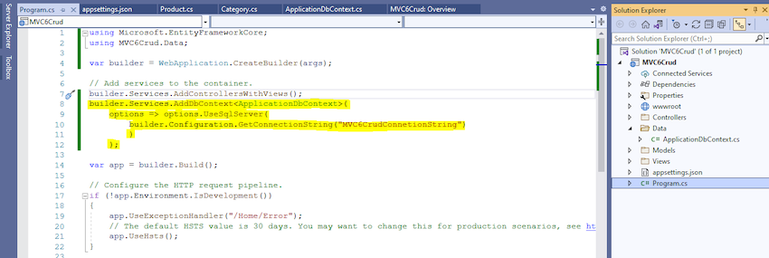

**Build solution**

**Step 7.** Run migration commands inside Package Manager Console (PMC) to create a Database

**Package Manager Console (PMC)**

**Add-Migration "Initial" command**

Update-Database command

MVC6CrudDb created into SQL Server with Categories and Products table.

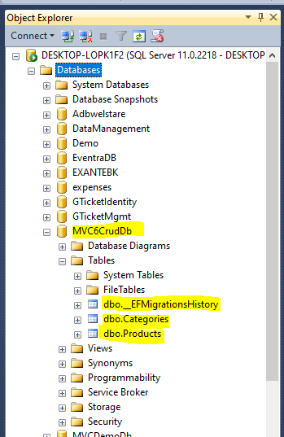

**Step 8.**Add the Category controller and Product controller in the controller folder

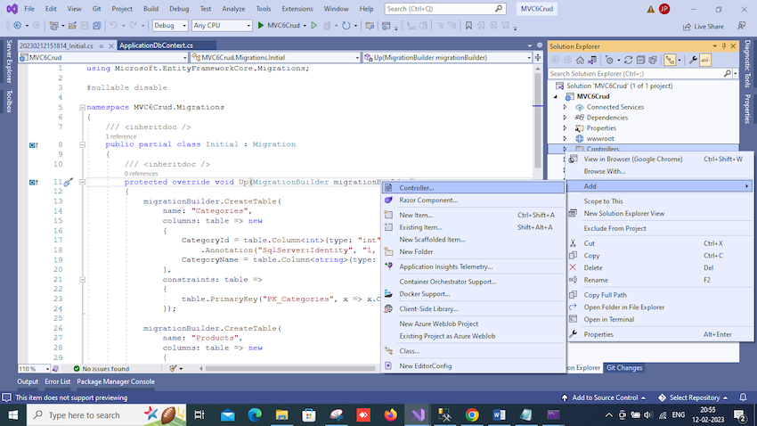

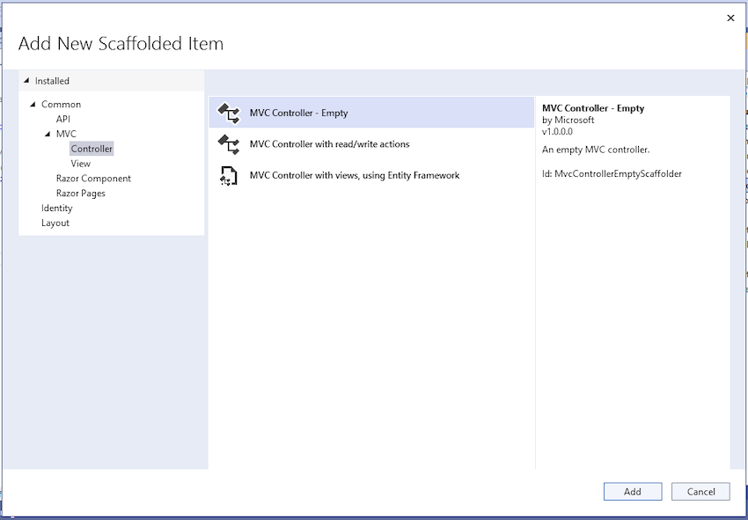

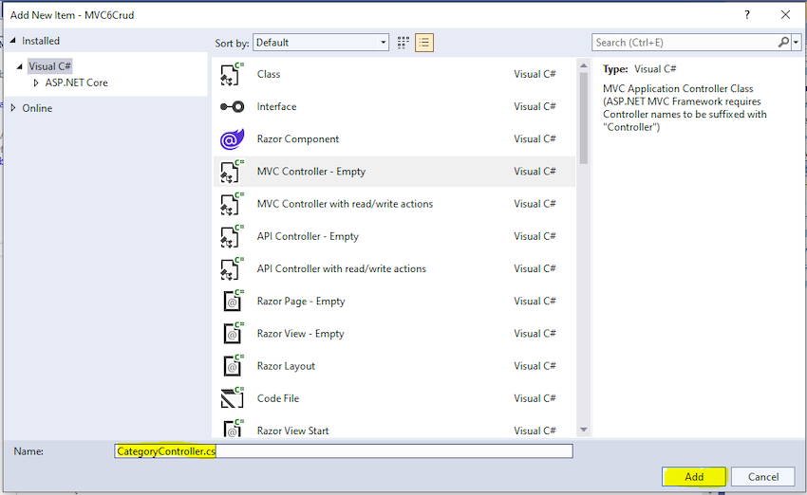

In the same way, we added a Product controller, and now both are showing in the controller folder.

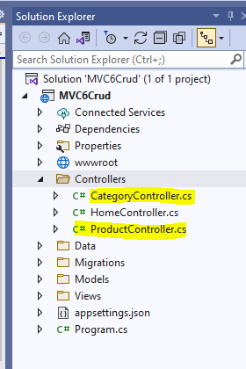

**Category CRUD operation screens**

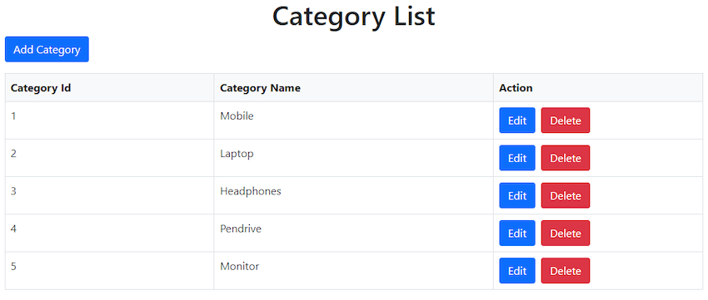

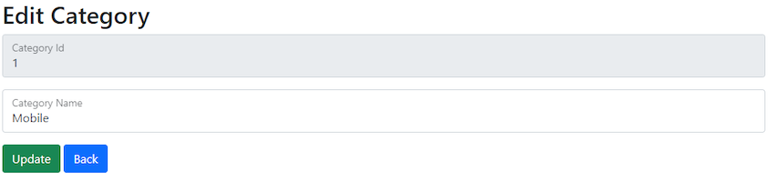

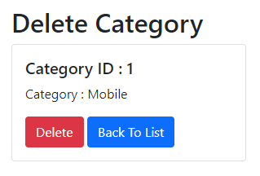

**Product CRUD operation screens**

